**Name:- Chaitanya Deshpande**

**Airline Data Management and Analysis Using Power BI**

**1. Data Preparation and Cleaning (10 Marks)**

**● Extract and transform data in Power Query.**

**● Clean data: remove duplicates, handle missing values, and format columns.**

**● Deliverables: Screenshot of Power Query Editor showing cleaned data.**

**Steps:-**

Load the three Excel files into Power BI via Power Query Editor.

Clean data:

* Remove duplicates using Remove Duplicates.
* Handle missing values using Remove Rows → Remove Blank Rows or fill/replace as needed.
* Format columns (e.g., convert date columns to Date format, IDs to text, etc.).

**Screenshots:-**

**i) Flight Information:-**

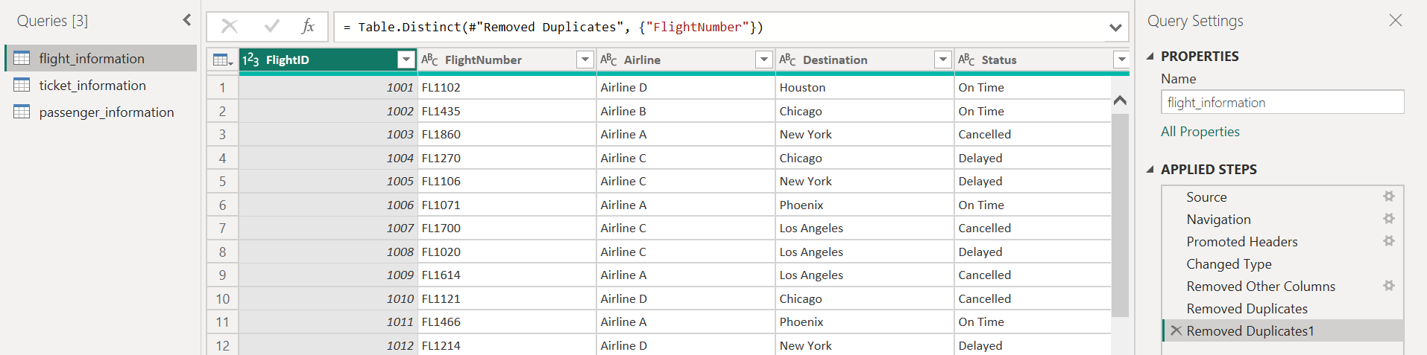

**ii) Ticket Information:-**

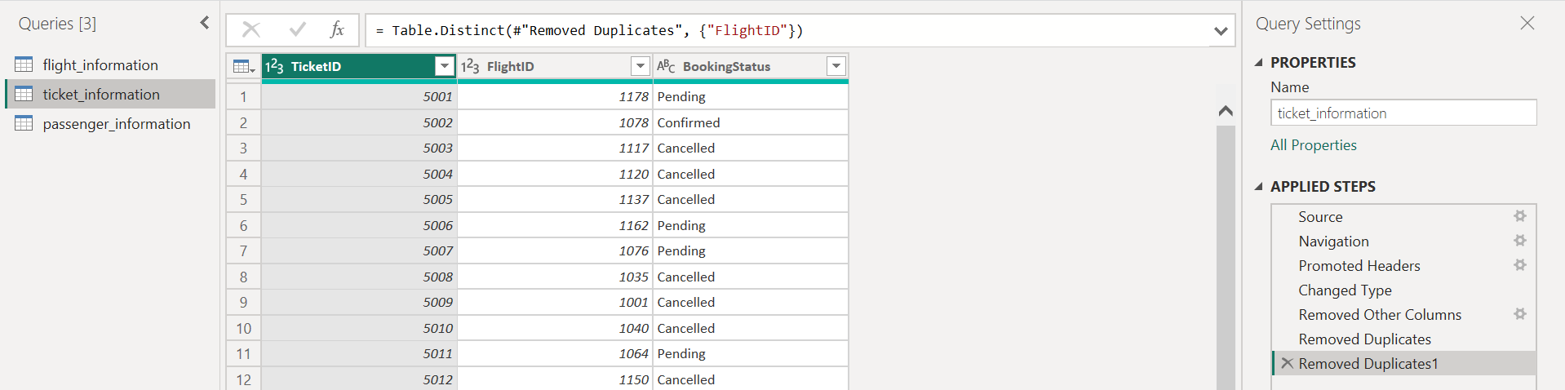

**iii) Passenger Information:-**

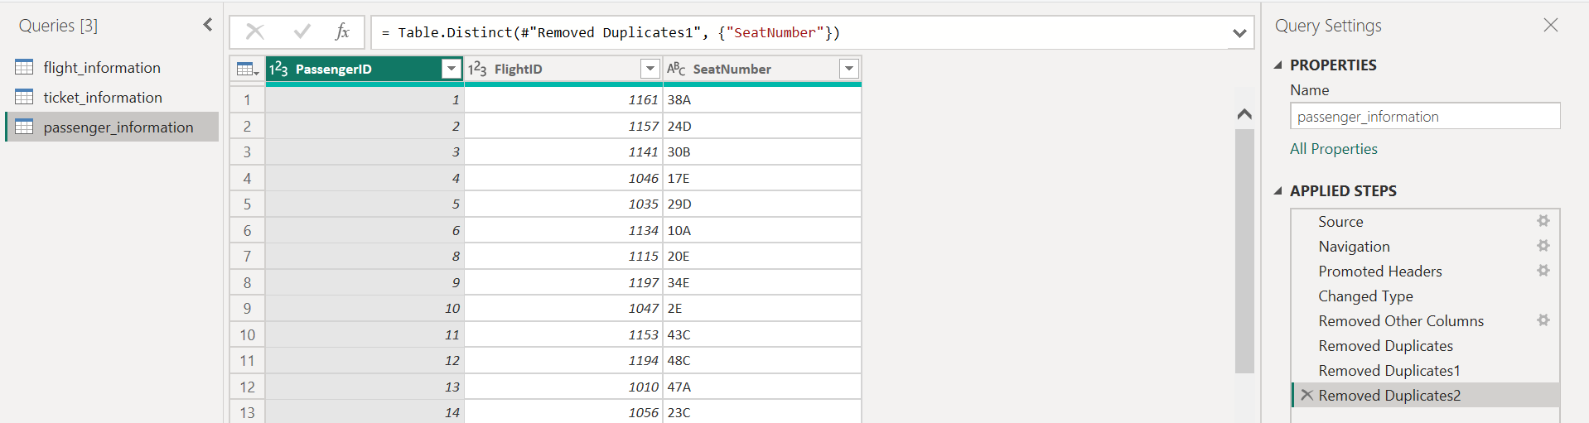

**2. Data Modeling (10 Marks)**

**● Create relationships between datasets (FlightID as the key).**

**● Understand cardinality and configure the model appropriately.**

**● Deliverables: Screenshot of the data model with relationships.**

**Steps:-**

Go to Model View.

Create relationships:

* Flight_Information[FlightID] → Ticket_Information[FlightID]
* Flight_Information[FlightID] → Passenger_Information[FlightID]

Ensure cardinality is "One-to-Many" from Flight_Information to both other tables.

**Screenshot:-**

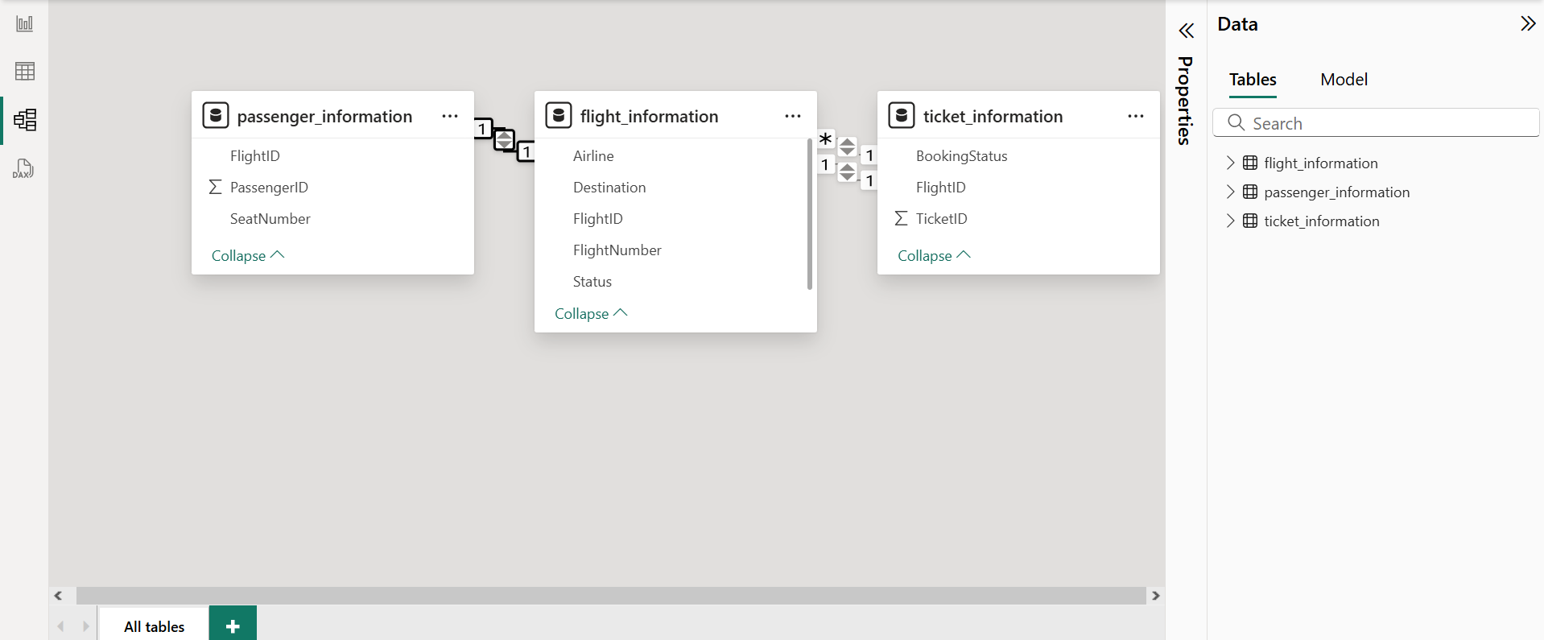

**3. Enhanced Data Insights (10 Marks)**

**● Add a conditional column to classify flights as "Best" or "To Be Improved" based on status.**

**● Use"Columnfrom Examples" to extract the flight number from FlightNumber.**

**● Deliverables: Screenshot of the transformed data.**

**Steps:-**

* In Power Query:
  + Add a conditional column in Flight_Information:  
    = if [Status] = "On Time" then "Best" else "To Be Improved"
  + Use Column From Examples to extract flight number from FlightNumber (e.g., extract numeric part).

**Screenshots:-**

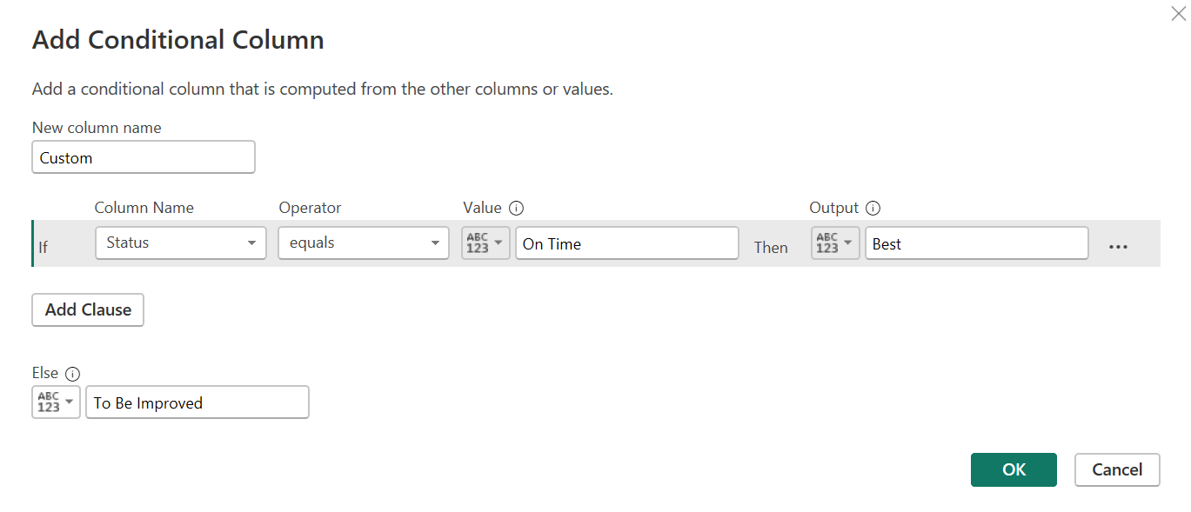

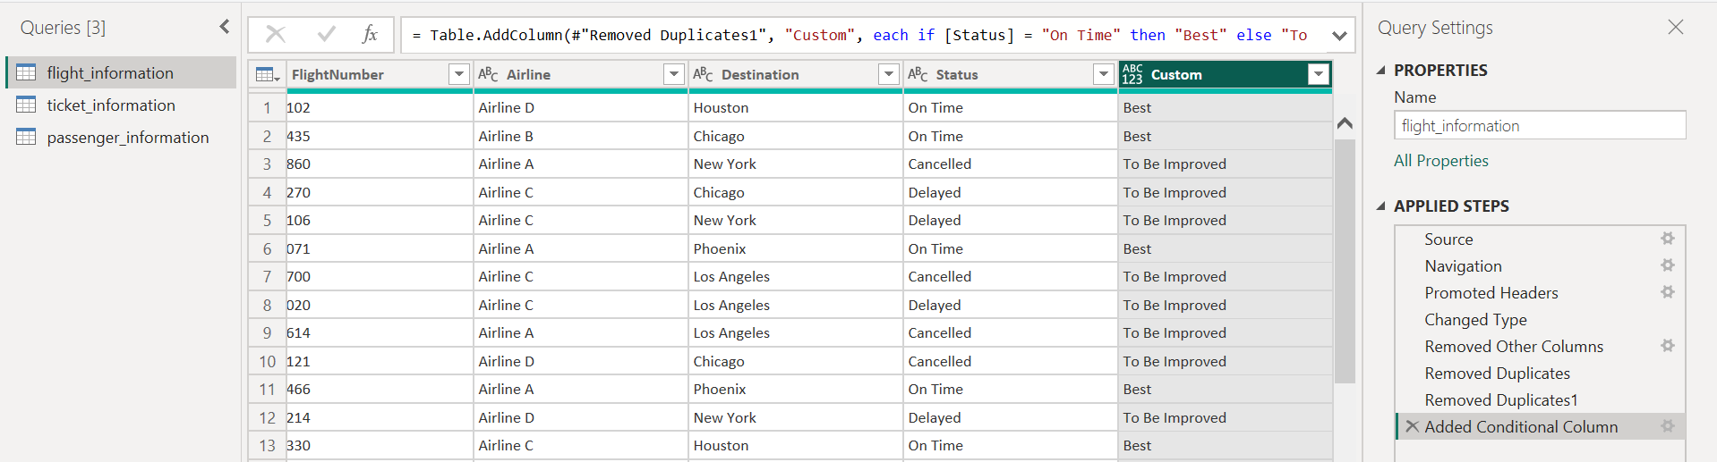

**4. Calculations Using DAX (10 Marks)**

**● Calculate:**

**○ Total passengers for a specific flight.**

**○ Total tickets booked.**

**○ Filtered table showing "Best" flights only.**

**● Deliverables: Screenshot of DAX calculations and results.**

**Dax Query:-**

**Flight Information:-**

“BestFlights =

FILTER(Flight_Information, Flight_Information[FlightClass] = "Best")”

**Passenger Information:-**

“TotalPassengers = COUNTROWS(Passenger_Information)”

**Ticket Information:-**

“TotalTicketsBooked = COUNTROWS(Ticket_Information)”

**Screenshots:-**

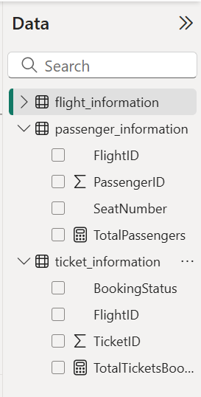

**5. Visualization and Interactive Features (20 Marks)**

**● Create visuals for:**

**○ Passenger count by airline.**

**○ Ticket booking statuses.**

**○ Flights by airline and destination.**

**● Add interactive features for:**

**○ Destination and Airline.**

**○ Quick views.**

**○ Airline-specific pages.**

**● Deliverables: Screenshots of all visuals and interactive features.**

**Steps:-**

Create visuals:

* Passenger count by airline → Bar chart.
* Ticket booking status → Pie chart.
* Flights by airline & destination → Matrix or stacked bar chart.

Add slicers for:

* Destination
* Airline

Use Page Navigation for airline-specific pages.

Add Quick Views using bookmarks and buttons.

**Screenshots:-**

**Passenger Count By Airline:-**

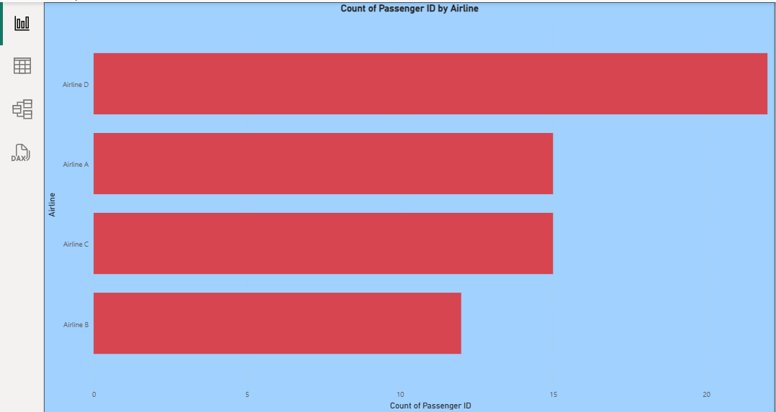

**Ticket Booking Status:-**

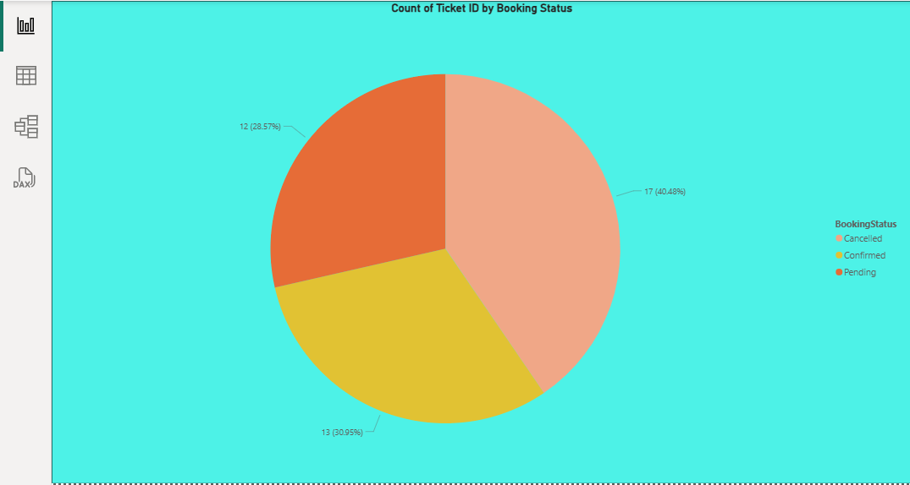

**Flights By Airline and Destination:-**

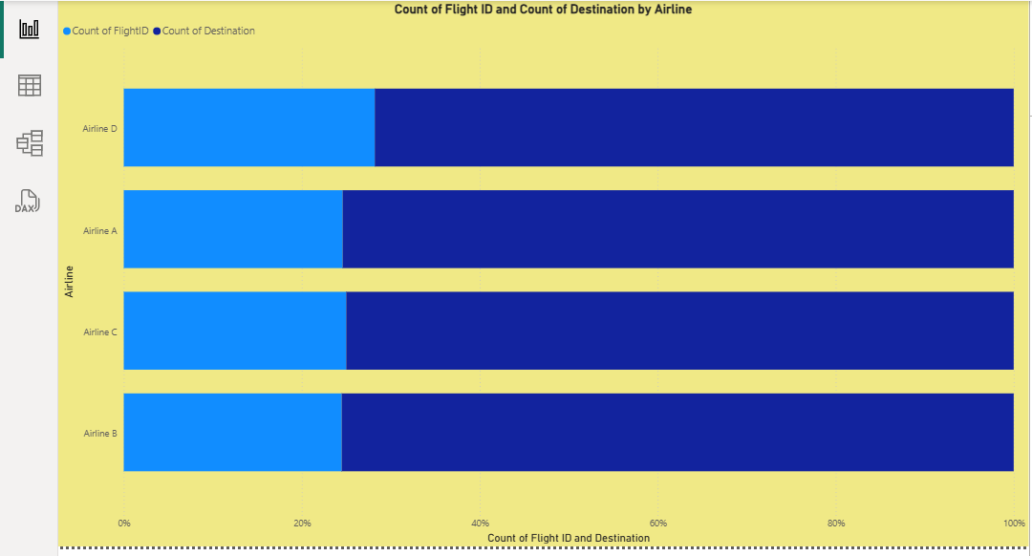

**Slicer:-**

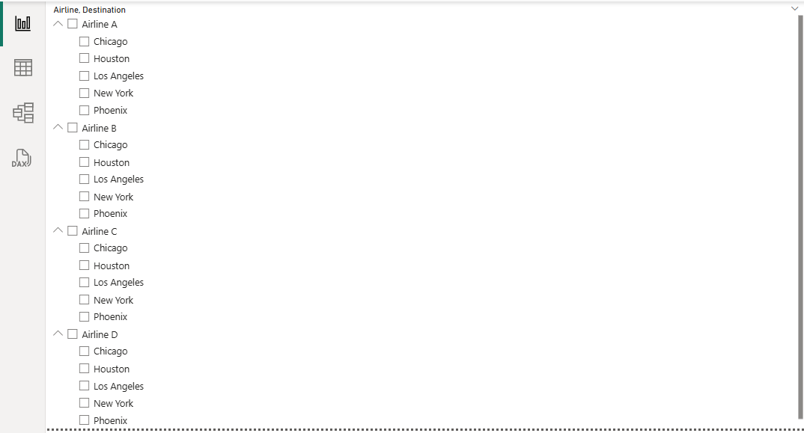

**6. Final Dashboard and Power BI Service (20 Marks)**

**● Design a comprehensive dashboard with key visuals and insights.**

**● Configure Row-Level Security (RLS) for Airline A data and assign it to a user.**

**● Setup a schedule refresh at 5 PM daily.**

**● Deliverables: Screenshot of the published dashboard and RLS configuration.**

**Screenshots:-**

**Published Dashboards:-**

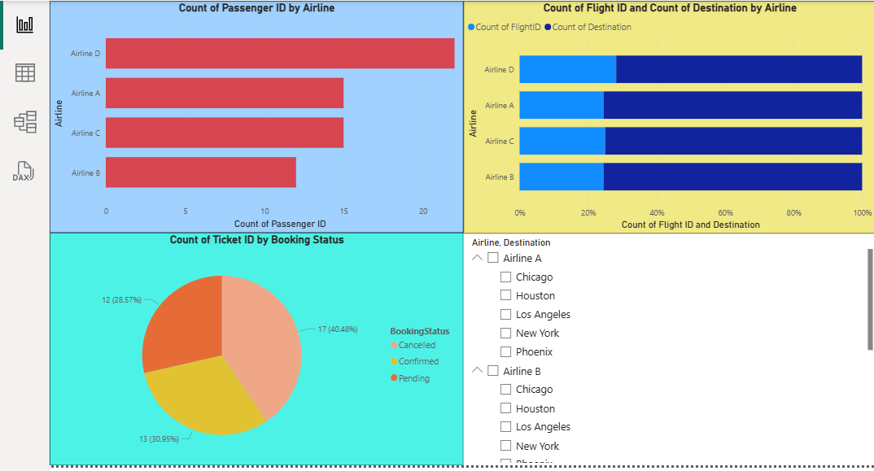

**RLS Role Setup:-**

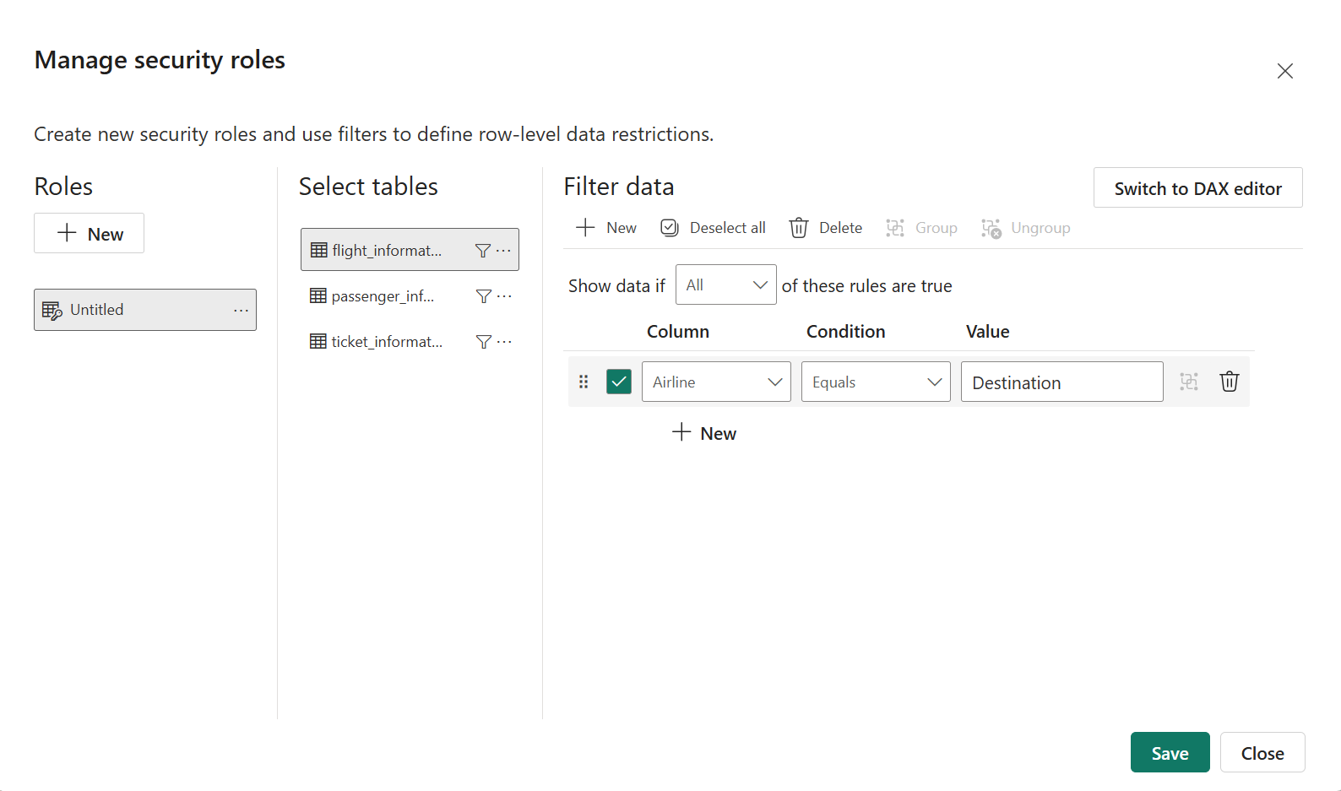

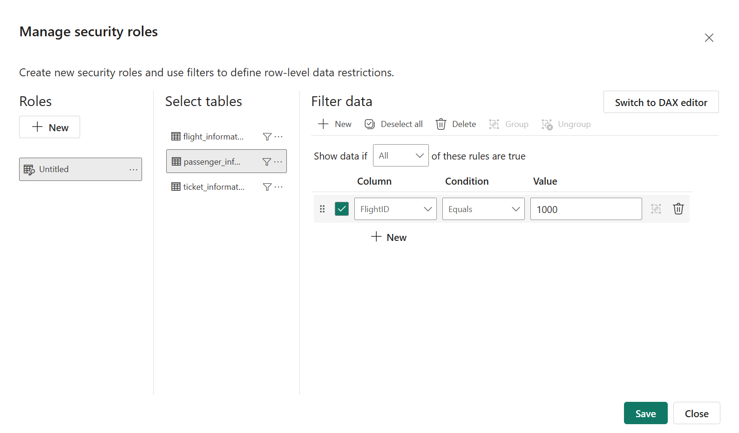

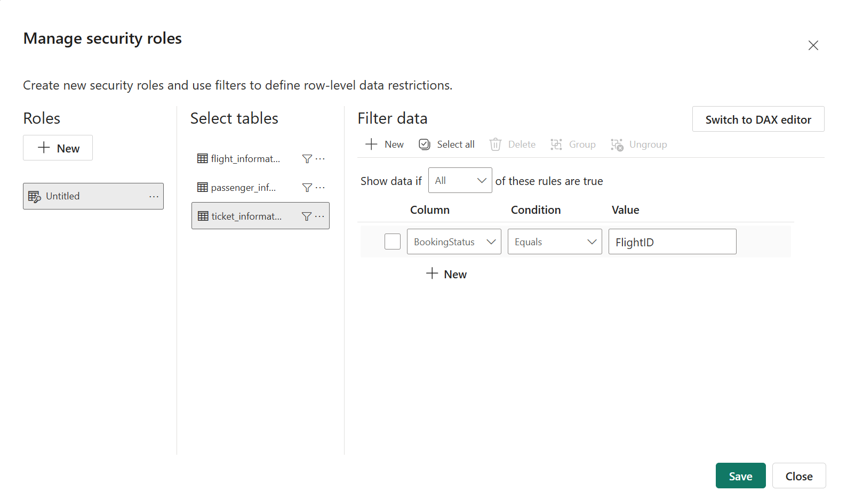

**Scheduled Refresh:-**

